Children ADHD Disease Detection using Pose Estimation Technique

Attention Deficit Hyperactivity Disorder (ADHD) disease mostly found in children’s and this disease can be detected by analysing children’s pose estimation. Currently no such technique exists to detect ADHD automatically and can be detected using manual monitoring but this technique is error pone and difficult to detect.

To overcome from above issue we are employing machine learning SVM algorithm which will get trained on normal and abnormal children’s poses and then it will analyse pose from new test images or videos to predict weather children post is normal or contains ADHD abnormal poses.

To train SVM we have used below pose dataset which contains children motions

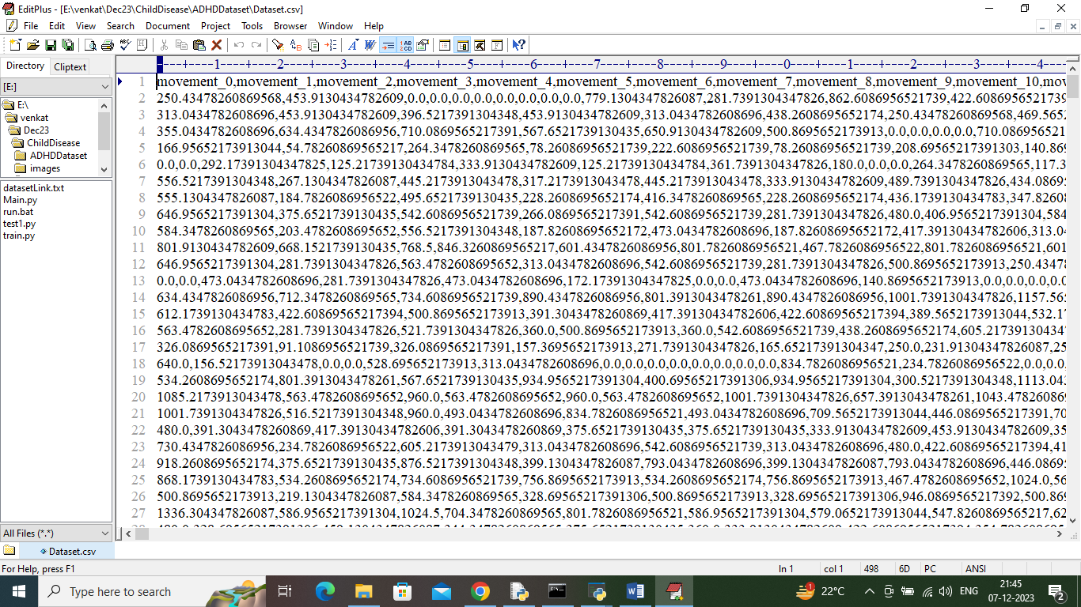

In above dataset screen first row represents dataset column names and remaining rows represents dataset values and in last column we have class labels as 0 or 1 where 0 represents NORMAL and 1 represents ADHD disease.

To implement this project we have designed following modules

1. Upload ADHD Pose Dataset: using this module we will upload dataset and to application and then read all dataset values
2. Pre-process Dataset: using this module we will clean, normalized and shuffle dataset values
3. Split Dataset Train & Test: using this module dataset will be split into train and test where application using 80% dataset records for training and 20% for testing
4. Train SVM Algorithm: 80% dataset will be input to SVM algorithm to train a model and this model will be applied on 20% test data to calculate prediction accuracy
5. Disease Detection from Test Image: using this module we will upload test image and then calculate or estimate poses and then applied SVM algorithm to predict weather image is normal or abnormal
6. Disease Detection from Video: using this module we can predict ADHD from videos also

SCREEN SHOTS

To run project double click on run.bat file to get below screen

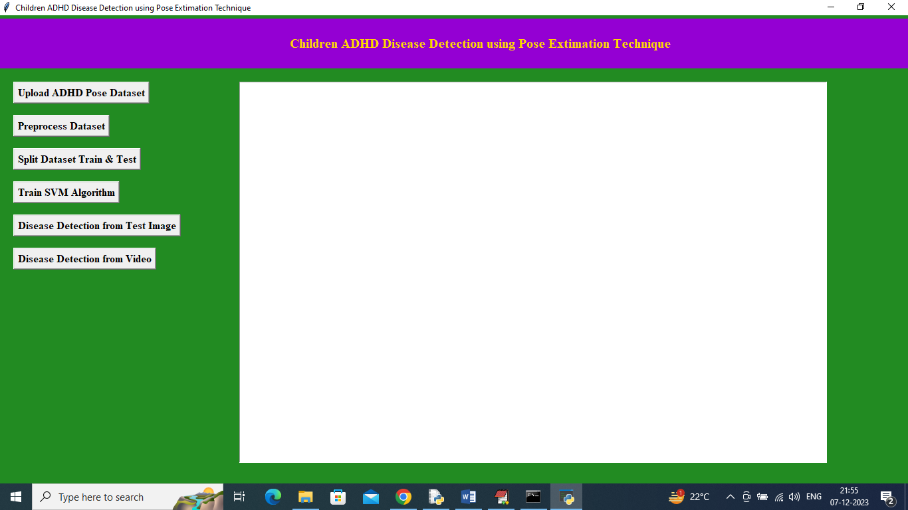

In above screen click on ‘Upload ADHD Pose Dataset’ button to upload dataset and get below output

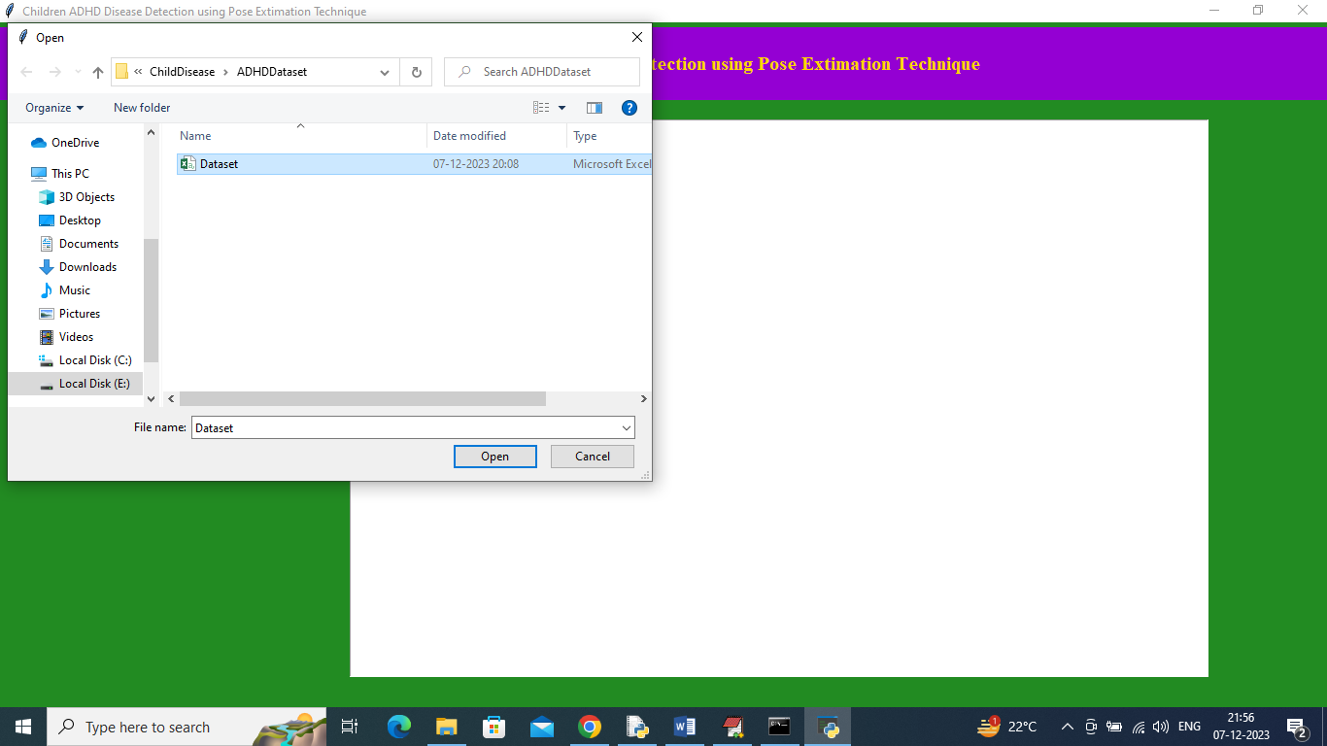

In above screen selecting and uploading dataset and then click on ‘Open’ button to load dataset and get below output

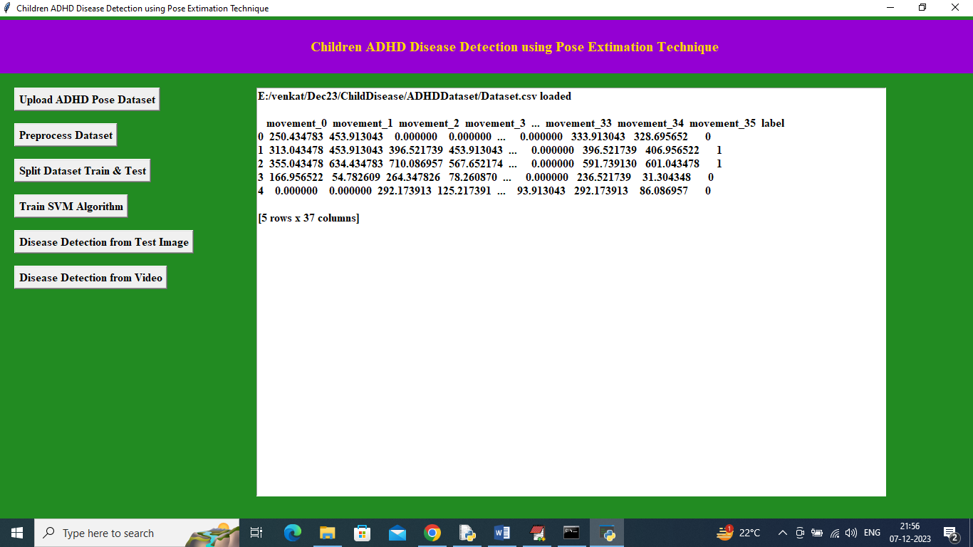

In above screen dataset loaded and now click on ‘Pre-process Dataset’ button to clean, normalized and shuffle dataset values

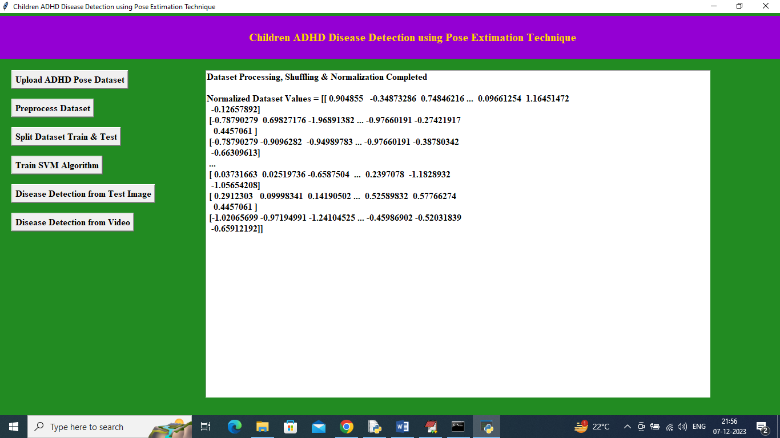

In above screen can see dataset is normalized and now click on ‘Split Dataset Train & Test’ button to split dataset into train and test and then will get below output

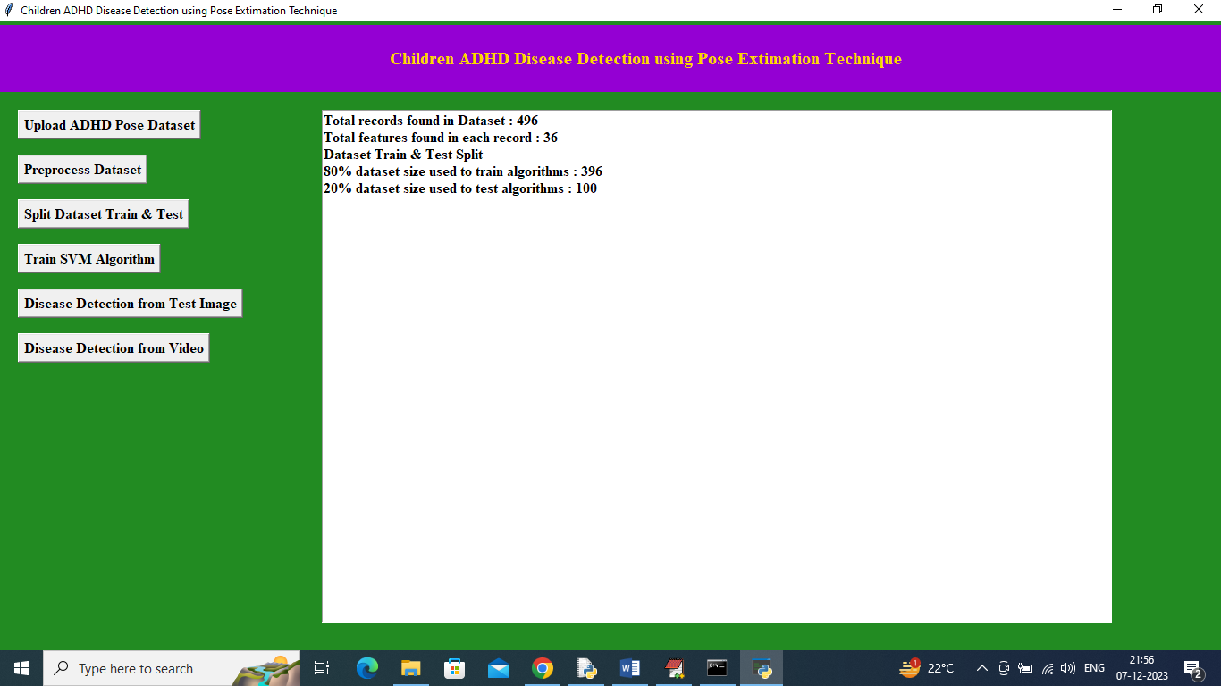

In above screen can see dataset total size and then can see training and testing size and now click on ‘Train SVM Algorithm’ button to train SVM and get below output

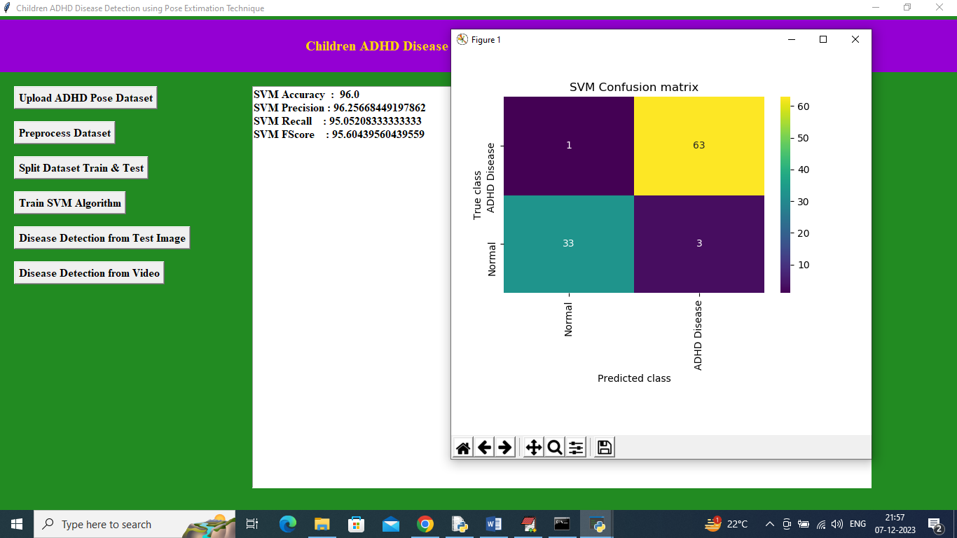

In above screen SVM training completed and it got 96% accuracy and can see other metrics like precision, recall and FCSORE. In above confusion matrix graph x-axis represents Predicted Labels and y-axis represents True Labels and green and yellow boxes contains correct prediction count and all blue boxes represents incorrect prediction which are very few. Now close above graph and then click on ‘Disease Detection from Test Image’ button to upload test image and get below output

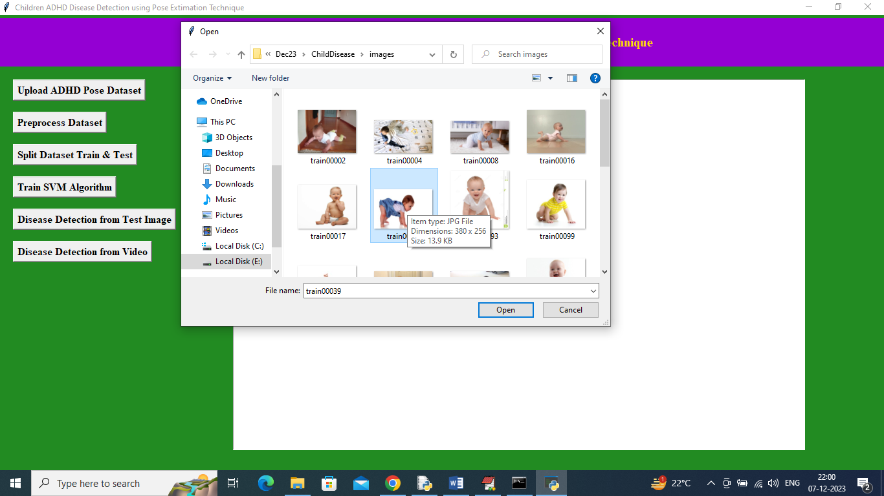

In above screen selecting and uploading test image and then click on ‘Open’ button to get below output

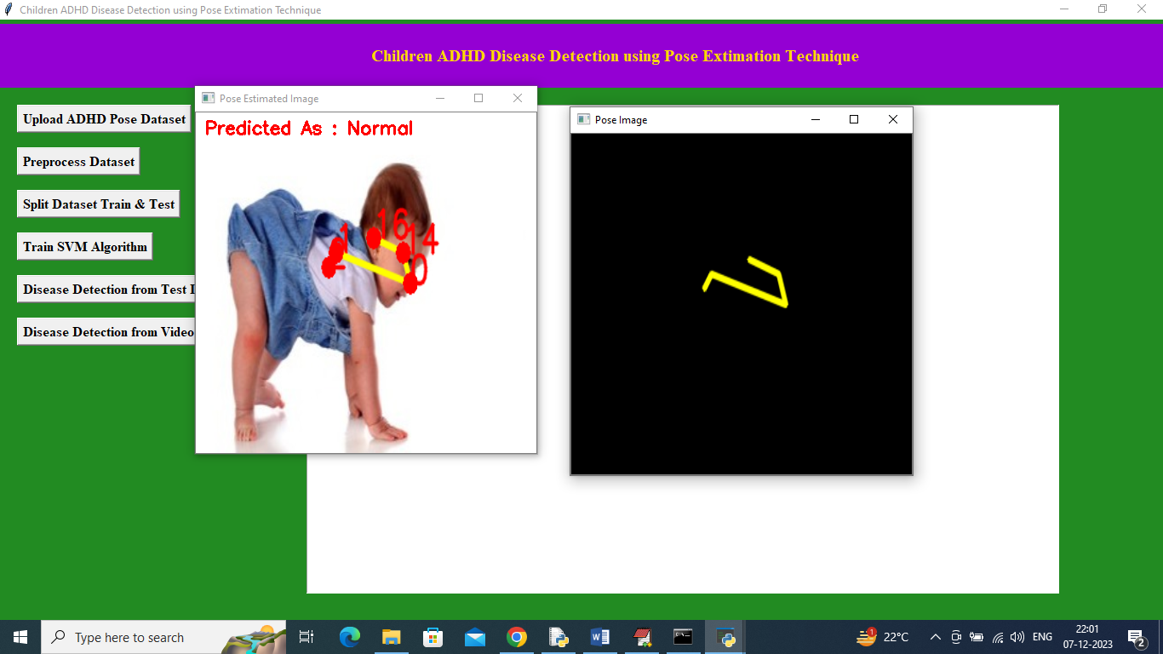

In above screen pose is estimated and that estimated pose drawn in black window also and image predicted as Normal and similarly you can upload and test other images

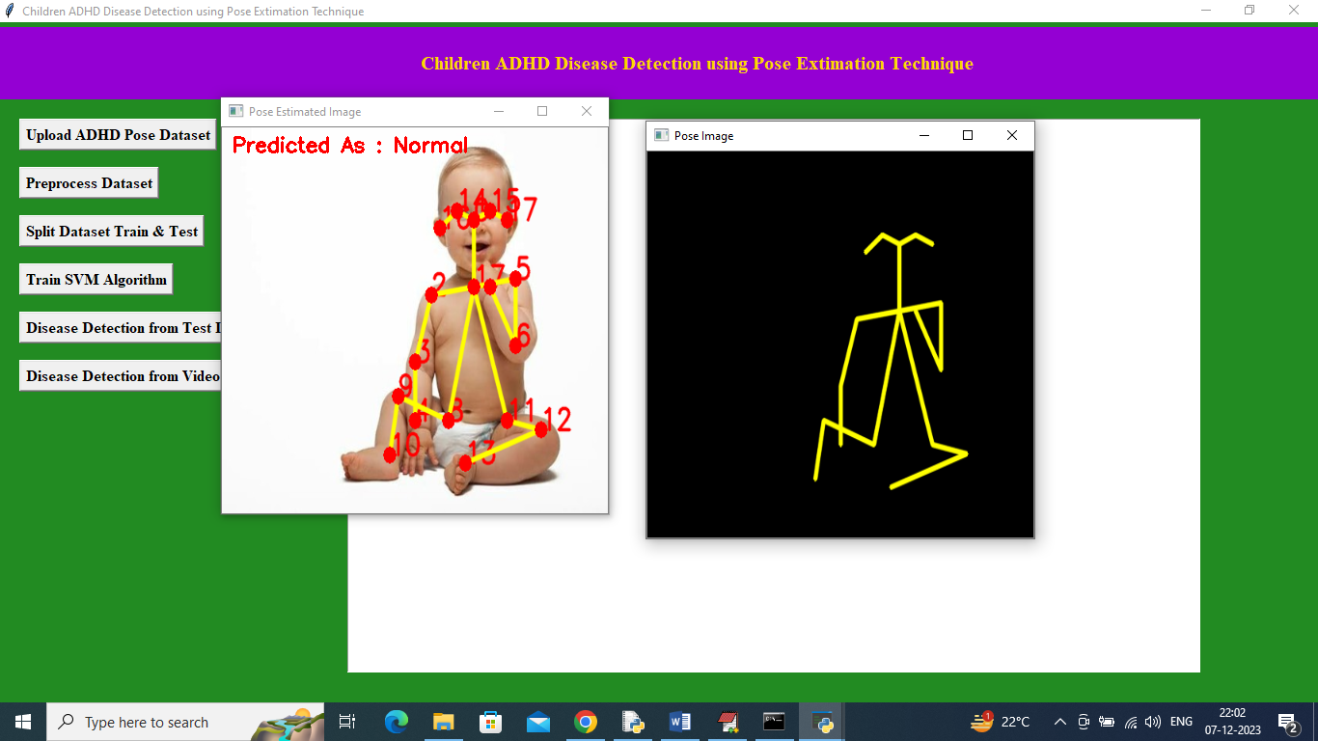

In above screen can see another image output

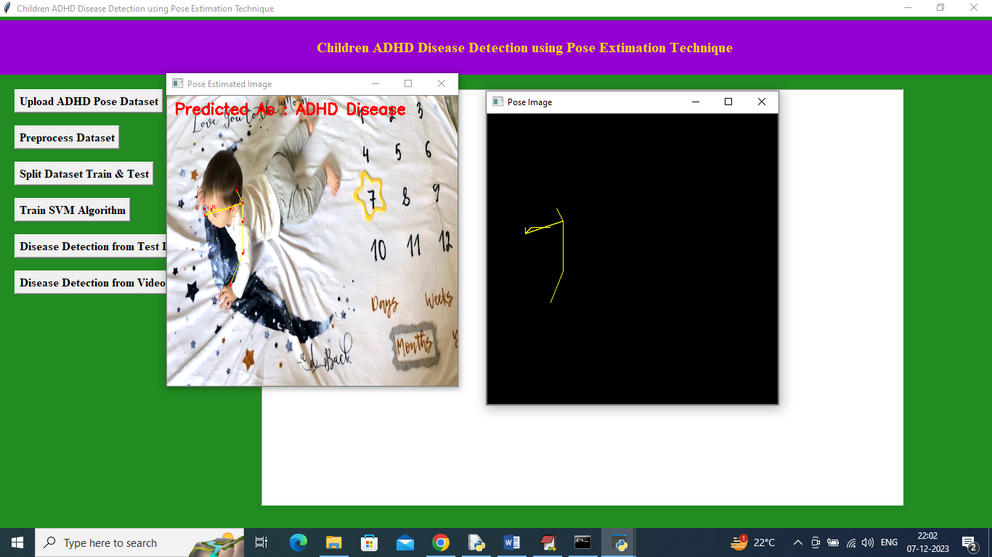

In above screen from pose ADHD disease detected and now click on ‘Disease Detection from Video’ button to upload video and get below output

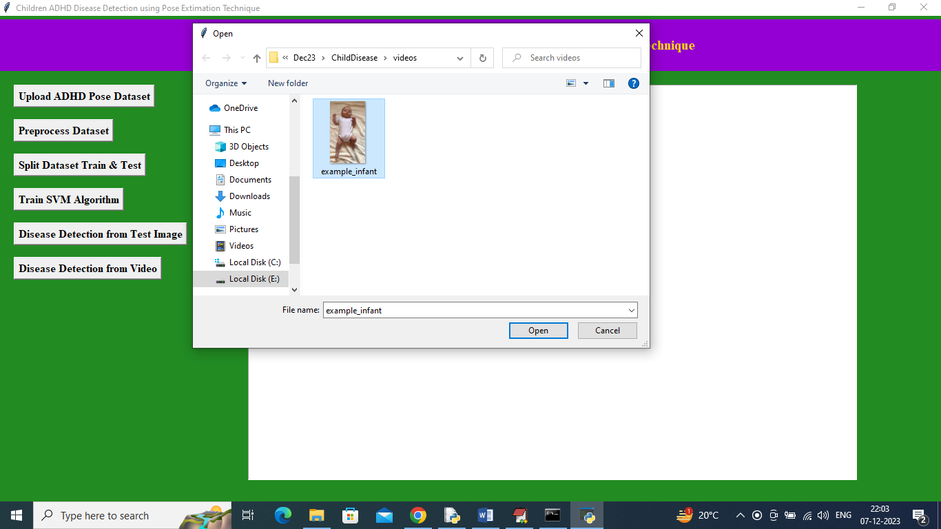

In above screen uploading video and then application will analyse all poses from video and then give prediction output

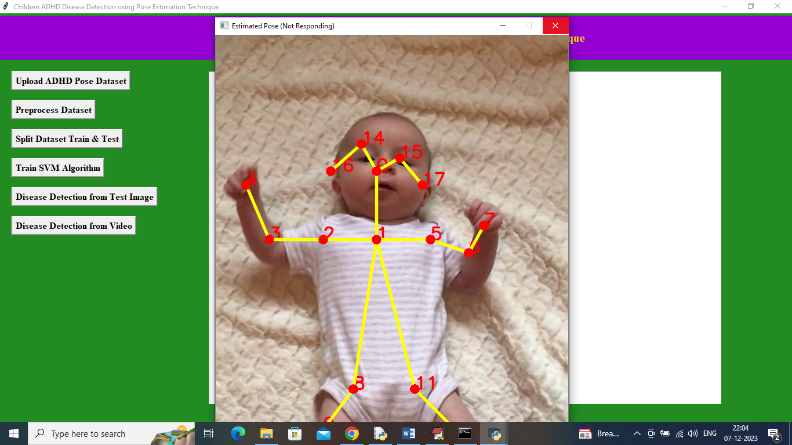

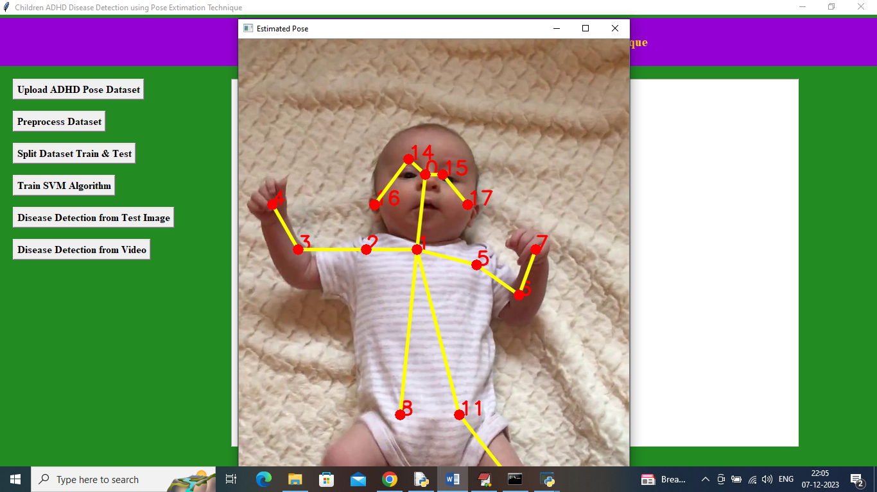

In above screen can see application start estimating poses from video and after completing video playing will get below output

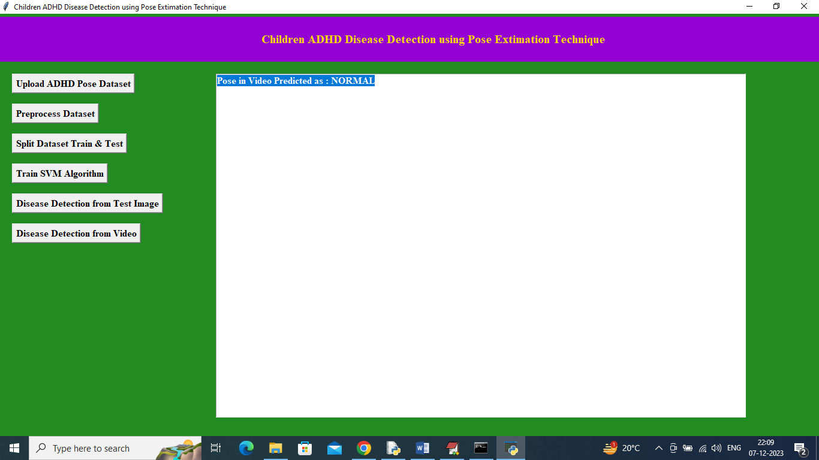

In above screen in blue colour text can see estimated poses from video detected as ‘Normal’.

Similarly by following above screens you can detected ADHD from any child image or video